MANUAL TESTING FINAL ASSESSMENT
LILIT ISKANDARYAN
EXAMINER: MARIA MANUKYAN

Requirement
User Story:
**As an admin user I can configure discounts for courses from my account.
**As a non admin user I can buy courses with discounts configured by admin.
Acceptance Criteria:
Admin user navigate to User_Action. “Change Discount” button is visible.
Change discount screen contains
- Course Type ddl with Advanced and Fundamental options
- discount which is numeric
- course_count field which is numeric
Change Discount button, after submission admin see notification – ‘Discount changes’
Non admin user login to the system, buy Fundamental and Advanced courses. Price should be shown already discounted(take into account admin configuration). Notification- ’You have xxx discount. Discounted price displays.’

Suggestions
- Clarify Role Definitions:
  - Ensure there’s a clear role management system in place to differentiate between Admin and Non-admin users.
- Validation Rules:
  - Define allowed ranges and validation rules for:
    - Discount (e.g., min/max % values, is it a flat amount or percentage?).
    - course_count (e.g., is 0 allowed?).
- Discount Application Logic:
  - Clarify whether discount applies:
    - Per course or total price?
    - To the first course_count the number of purchases?
  - Should discount apply if the user buys more than the configured count?
- User Interface Suggestions:
  - The Change Discount screen should ideally display current discount configurations for transparency.
  - Add confirmation modal/dialog before submitting discount changes.
- Persistence Check:
  - Ensure discount settings are saved persistently and can be retrieved even after logout/restart.
- Audit Log / Change Tracking:
  - Should changes made by admin be logged for audit purposes?
- Multiple Discounts / Time Limit:
  - Should there be support for multiple discounts for different durations, or is it one static configuration?
- API Security:
  - Ensure only Admins can access the "Change Discount" endpoint.
  - Ensure discount is not modifiable through browser tools by regular users.
- Cross-Browser & Device Testing:
  - UI for both admin and non-admin user flows should be tested on multiple browsers and screen sizes.
- Notification Visibility:
  - Ensure user notifications (like "Discount changes", “You have xxx discount”) are shown clearly and disappear appropriately (or are dismissible).
  - After Non-admin user buys a course, message can appear on the screen that “Congratulations, …..,purchase is successfully done”

Requirement Clarification Questions (To be Asked to Client/BA)
- Discount Value Type:
  - Is the discount a percentage or fixed amount?
  - Is it applied per course or overall purchase?
- ’You have xxx discount. Discounted price displays.’

- Does it mean exactly that text will be shown?
- Or it means numeric discounted price will be displayed such as “5$”

- Course Count Field:
  - What does course_count represent?
  - Max number of courses per user that can be discounted?
  - Is it a limit on total discounts or per-user discount limit?
- Multiple Course Purchases:
  - If a user purchases both course types in one transaction, is the discount applied to both?
  - Should the discount apply to bundles or only individual purchases?
- Discount Lifetime:
  - Is the discount permanent until changed by Admin, or should it have an expiration?
- UI Behavior:
  - Should the current discount configuration be shown to Admin on screen load?
- Default Values:
  - Are there default discount values when the system starts or when no configuration is done?
- Notification System:
  - Should notifications be shown as modals, toast messages, or inline messages?
- Access Control:
  - What happens if a non-admin tries to access the Change Discount screen via URL manipulation?
- Historical Pricing:
  - Do we need to track discount history or just maintain current value?
- Discount Conflict Handling:
  - How should the system behave if two admins update discounts simultaneously?
- Testing Environments:
  - Will a staging environment be available for testing these scenarios?

QA Checklist

Role-Based Access Control
- Only Admin users can see and access the "Change Discount" button.
- Non-admin users cannot access the discount configuration screen via direct URL or API.

Admin Discount Configuration Screen
- “Change Discount” screen is accessible from User_Action for Admin users.
- Course Type dropdown contains only two options: “Fundamental” and “Advanced”.
- Discount field accepts only numeric values (validate min/max if specified).
- “User_Action” field accepts only numeric values (validate zero and negative cases).
- “Change Discount” button is enabled only when valid inputs are entered.
- After submission, a success notification “Discount changes” is displayed.

Discount Application for Non-Admin Users
- Discounted price is automatically applied to courses (Fundamental and Advanced).
- Notification “You have xxx discount. Discounted price displays.” is shown.
- Price displayed is calculated based on the current discount configuration.
- Discount application is limited according to the course_count rule if applicable.

Functional & Data Persistence Checks
- Discount configuration persists after logout or page refresh.
- Changes to discounts reflect immediately (or with expected delay) for non-admin users.
- Only the latest discount configuration is applied.

Negative Scenarios
- Validation errors are shown for invalid discount (e.g., >100%, negative value).
- Validation errors for invalid course count (e.g., decimals, text).
- Non-admin users do not see the “Change Discount” screen.

Cross-Testing
- Functionality is consistent across major browsers (Chrome, Yahoo, Edge).
- Functionality works correctly on mobile and tablet devices.

What kind of Testing Can be Done
API Testing in POstman,
Performance testing in JMeter
Database testing in MySQL Workbench
Database testing using CMD
What Can Be Checked in CMD
Check Type | What Can Be Done
Functional Testing | Used curl to simulate login, discount setup, purchase
DB Validation | Used mysql CLI to run SQL queries
Performance Testing | Used curl, ab, or basic loops to measure latency
Monitoring | Used tasklist or resmon for system resource checks

BUG REPORT
🐞 Bug Report 1
Field | Description
Bug ID | BUG-001
Title / Summary | alphabetics, symbols, negative numbers accepted in the “Discount” field
Reported By | Lilit Iskandaryan
Date Reported | 16.05.2025
Environment | OS, browser Chrome
Severity | Critical
Priority | High
Module | Discount Configuration, Course Purchase
Preconditions | Logged in as Admin user
Steps to Reproduce | 1. Login as admin  2. Navigate to User_Action  3. Click “Change Discount” button  4. Click “discount” field  5. Input data “==”, “hii”, “-1”
Expected Result | Validation errors should be displayed on the screen, Discount should not be changed.
Actual Result | Input data was accepted and Acceptance message appeared “Discount is changed”
Log Output / Console | 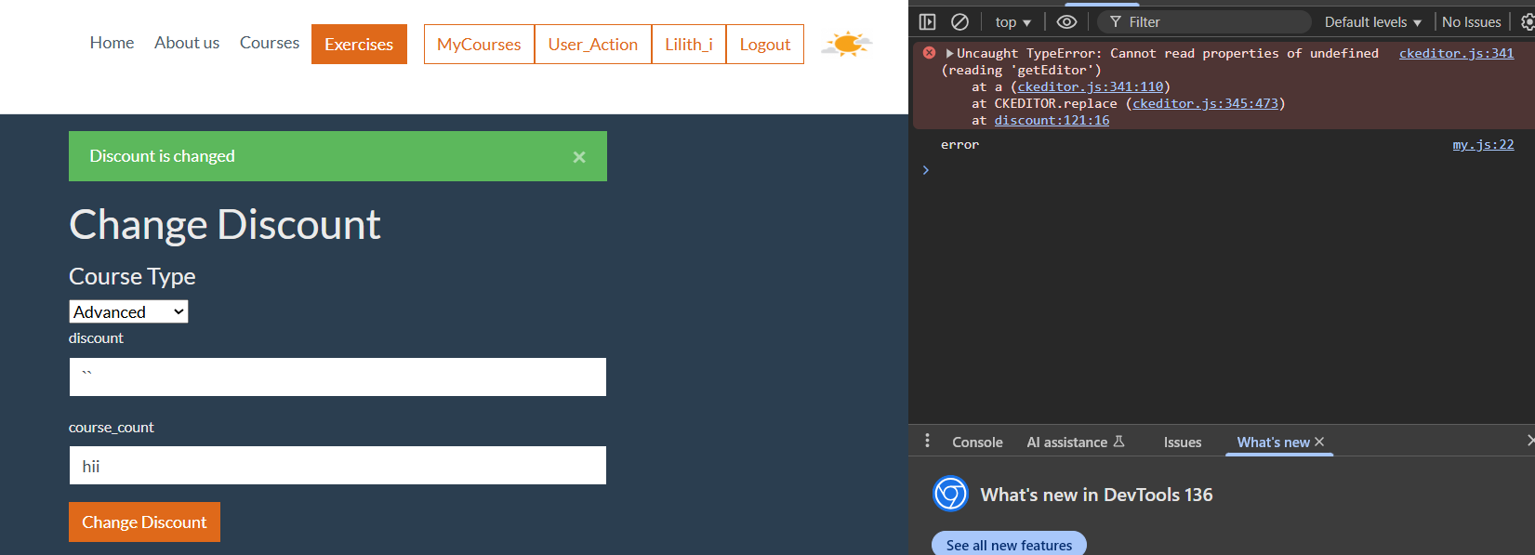
Bug Status | New
Assigned To | Lilit Iskandaryan

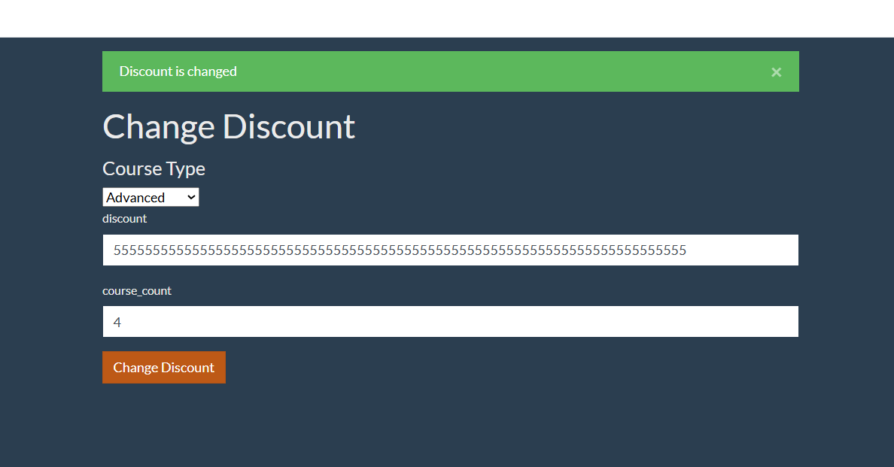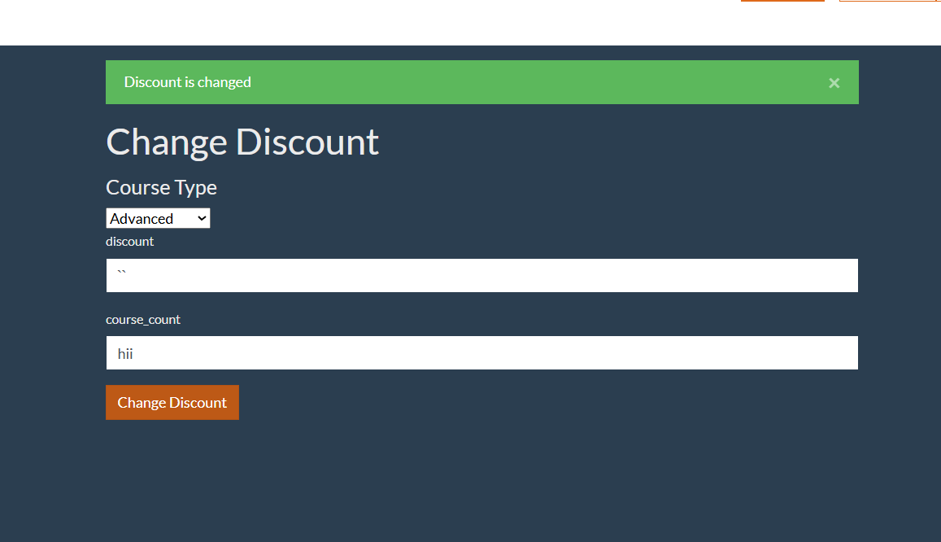
🐞 Bug Report 2
Field | Description
Bug ID | BUG-002
Title / Summary | alphabetics, symbols, negative numbers accepted in the “Course_counts” field
Reported By | Lilit Iskandaryan
Date Reported | 16.05.2025
Environment | OS, browser Chrome
Severity | High
Priority | High
Module | Discount Configuration, Course Purchase
Preconditions | Logged in as Admin user
Steps to Reproduce | 1. Login as admin  2. Navigate to User_Action  3. Click “Change Discount” button  4. Click “course_count” field  5. Input data “==”, “hii”, “-1”, “////”
Expected Result | Validation errors should be displayed on the screen, Discount should not be changed.
Actual Result | Input data was accepted and Acceptance message appeared “Discount is changed”
Log Output / Console | 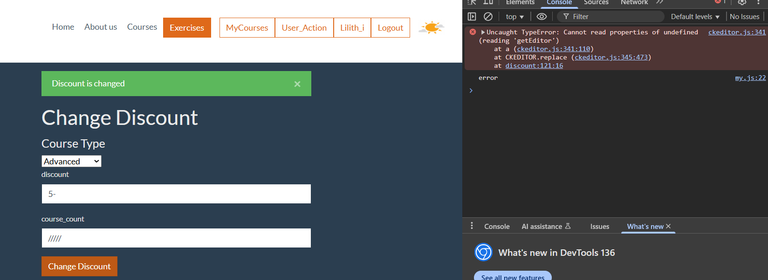
Bug Status | New
Assigned To | Lilit Iskandaryan

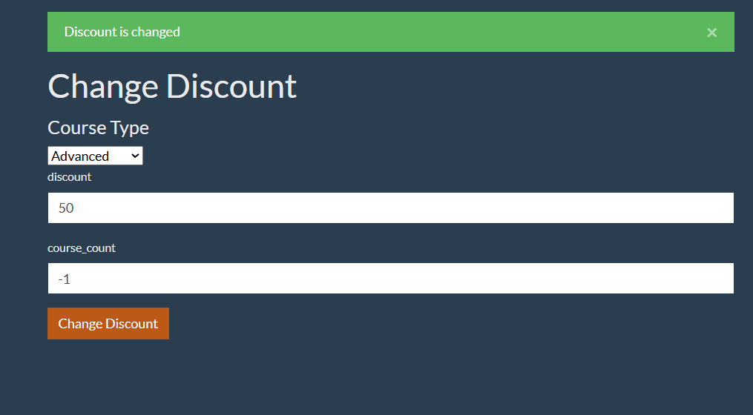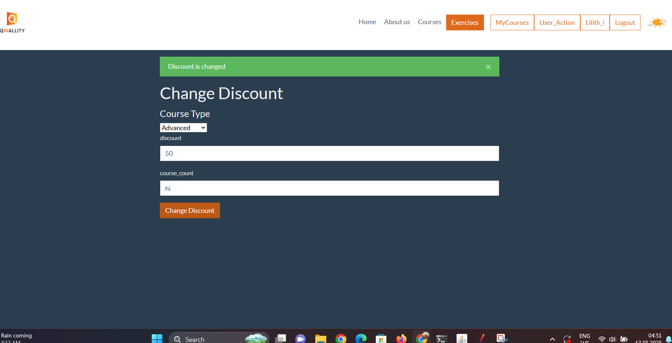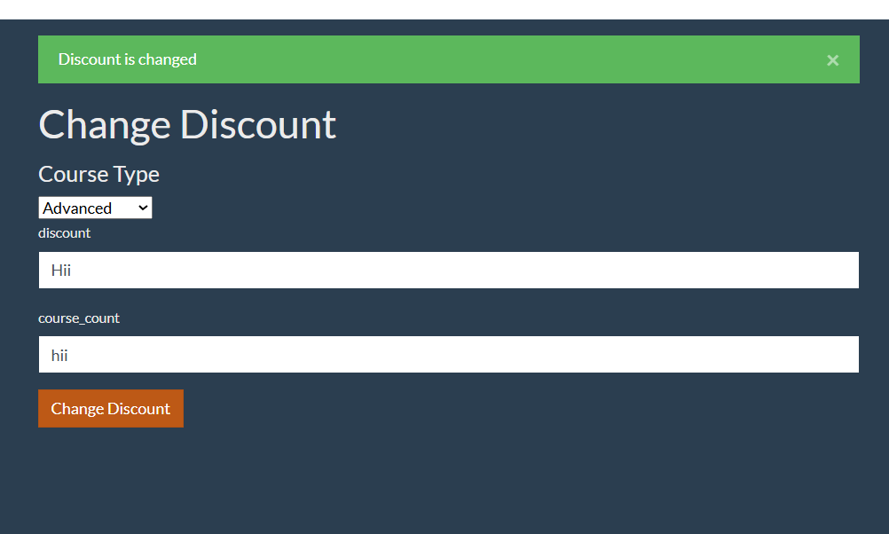

Bug3: Admin users
🐞 Bug Report 3
Field | Description
Bug ID | BUG-003
Title / Summary | “Chosen course_type‘ changes to “Advanced” immediately after clicking on the “change discount” button, however input data still is displayed
Reported By | Lilit Iskandaryan
Date Reported | 16.05.2025
Environment | OS, browser Chrome
Severity | Mid
Priority | Medium
Module | Discount Configuration, Course Purchase
Preconditions | Logged in as Admin user
Steps to Reproduce | 1. Login as admin  2. Navigate to User_Action  3. Click “Change Discount” button  4. Click “course_type” field  5. Choose “Fundamental”  6. Click on “Change discount”
Expected Result | After a discount set Either all input data should not be displayed and “course_type” will be automatically set as “Advanced” (2nd type), or if all data is still displayed, chosen course_type should remain as set .
Actual Result | All input data is still displayed, although “course_type” is unset.
Log Output / Console | 
Bug Status | New
Assigned To | Lilit Iskandaryan

🐞 Bug Report 4
Field | Description
Bug ID | BUG-004
Title / Summary | Null data is accepted for discount change
Reported By | Lilit Iskandaryan
Date Reported | 16.05.2025
Environment | OS, browser Chrome
Severity | Critical
Priority | High
Module | Discount Configuration, Course Purchase
Preconditions | Logged in as Admin user
Steps to Reproduce | 1. Login as admin  2. Navigate to User_Action  3. Leave both fields null  4. Click “Change Discount”
Expected Result | Validation errors should be displayed on the screen, Discount should not be changed.
Actual Result | Null data was accepted and Acceptance message appeared “Discount is changed”
Log Output / Console | 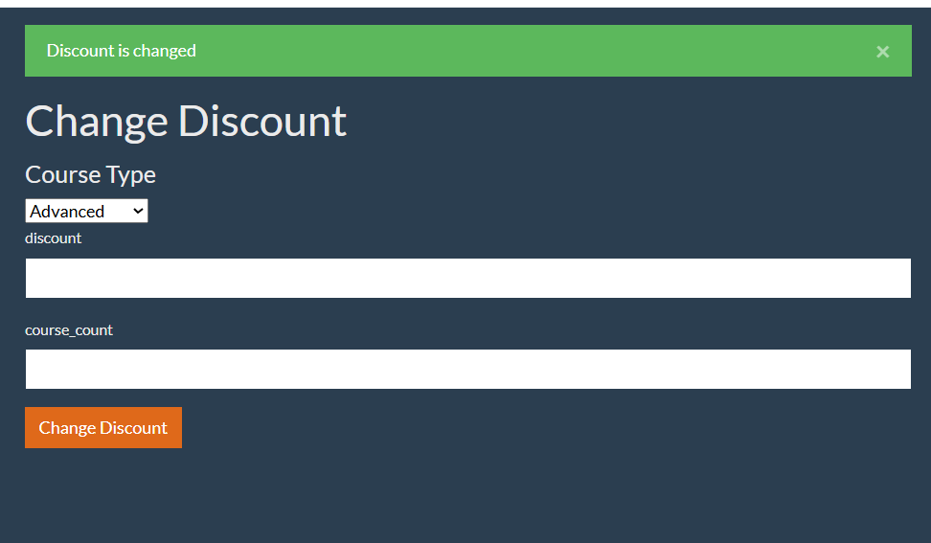
Bug Status | New
Assigned To | Lilit Iskandaryan


